

**Payment Gateway**

**Integration Guidelines**

**Version 5.0**

**Last Updated: 27th November 2015**

Copyright @ 2015 | The Codero Limited

Table of Contents

|  |  |  |
| --- | --- | --- |
|  | Content Title | Page No |
| 1 | Introduction | 2 |
| 2 | Payment Gateway Details | 2 |
| 3 | API Operations | 3 |
| 4 | cURL Method Sample PHP Codes | 7 |
| 4 | Payment Return Variables | 10 |
| 6 | Check Payment Status or Lookup API | 12 |
| 7 | Check Payment Status Sample Output XML | 15 |
| 8 | Check Payment Status Sample Output JSON | 16 |
| 9 | IPN URL | 17 |
| 10 | Payment Status Code Meaning | 19 |
| 11 | Frequently Asked Questions (FAQ) | 21 |
| 12 | Technical Support | 25 |

*EasyPayWay Gateway Integration Documentation || The Codero Limited @ 2015*

**1 Introduction**

The EasyPayWay.com Payment Gateway enables Merchants to receive money from their customers by temporarily redirecting them to **www.easypayway.com.** The gateway is connecting multiple payment terminal including card system, mobile financial system, local and International wallet.

After the payment is complete, the customer is returned to the Merchant's site and seconds later the Merchant receives notification about the payment along with the details of the transaction.

This document is intended to be utilized by technical personnel supporting the online Merchant's website. Working knowledge of HTML forms or cURL is required. You will probably require test accounts for which you need to open accounts via contact with easypayway.com or already provided to you.

For all merchant technical support, please contact our Merchant Service Department. Our technical support desk available 24/7 round the year.

Phone: + 88 01922 333 999 Email: support@easypayway.com

**2 Payment Gateway Details**

2.1 Implementation

The EasyPayWay.com Payment Gateway requires the Merchant to modify their payment page to include Credit/Debit Card as a payment option. Then, when the customer selects Credit/Debit Card as a payment method he is actually submitting an HTML form to EasyPayWay.com secure web servers. The submitted form contains information about the payment, as the Merchant's ID, amount to be paid and several other hidden text fields.

To Create the Credentials you need to provide below primary information

● Domain Name

● IP Address

● Email Address

● Phone Number

● Logo [ Maximum Height 100px and Maximum Width 300px ] png/jpg/gif format

*EasyPayWay Gateway Integration Documentation || The Codero Limited @ 2015*

API Operations

[ Web Version ]

EasyPayWay REST APIs are supported in two environments. Use the *Sandbox* environment for testing purposes, then move to the *live* environment for production processing. When testing, generate an order url with your *test credentials* to make calls to the Sandbox URIs. When you’re set to go live, use the live credentials assigned to your new signature key to generate a live order url to be used with the live URIs. Your server have to support cURL system. For HTML Form submit please review after cURL part we provide HTML Post method URL also.

The following *endpoints* address our two environments [ cURL Method ]:

● Sandbox (for testing) : [http://epwsandbox.com/payment/request.php](http://sandbox.easypayway.com/payment/request.php)

● Live (production) : https://securepay.easypayway.com/payment/request.php

For **Post Method** You need to change the calling url as below

● Sandbox (for testing) : [http://epwsandbox.com/payment/index.php](http://sandbox.easypayway.com/payment/index.php)

● Live (production) : https://securepay.easypayway.com/payment/index.php

**Variables Need to Post to Initialize Payment Process Order URL**

***\*\*Required fields Must Be posted otherwise integration will not work***

|  |  |  |  |
| --- | --- | --- | --- |
| **Field Name**  **(Parameters)** | **Description** | **Requi red** | **Example Value** |
| **Merchant Details** | | | |
| store_id | Your Merchant ID – Provided by  EasyPayWay | Yes | merchantid |
| tran_id | Reference or identification number provided by the Merchant. MUST be unique for each payment (Max 32 characters) | Yes | A205220 |
| success_url | URL to which the customer will be returned when the payment is made successfully. The customer will be returned to the last page on the Merchant's website where he should be notify the payment successful. | Yes | http://www.merchantdomain.com/suc esspage.html |

*EasyPayWay Gateway Integration Documentation || The Codero Limited @ 2015*

|  |  |  |  |
| --- | --- | --- | --- |
| fail_url | URL to which the customer will be returned when the payment is made. But the Payment not Accepted by bank or card have insufficient balance etc. The customer will be returned to the last page on the Merchant's website where he should be notify the payment failed. | Yes | http://www.merchantdomain.com/faile dpage.html |
| cancel_url | URL to which the customer will be returned if the payment process is cancelled. If this field is not filled, the gateway window will simply close automatically upon clicking the cancellation button, so the customer will be returned to the last page on the Merchant's website where the customer has been before. | Yes | http://www.merchantdomain.com/can cellpage.html |
| ipn_url | URL which easypayway will push the transaction details. Its required to confirm both party payment information updated to both party | No | http://www.merchantdomain.com/ipn_  confirm.php |
| opt_a | Optional Field for Merchant Record | No |  |
| opt_b | Optional Field for Merchant Record | No |  |
| opt_c | Optional Field for Merchant Record | No |  |
| opt_d | Optional Field for Merchant Record | No |  |
| **Payment Details** | | | |
| amount | The total amount payable. Please note that you should skip the trailing zeroes in case the amount is a natural number | Yes | 39.68  OR  39.6  OR  39 |
| payment_type | Payment process card type that customer want to pay with | No | VISA |
| currency | 3­letter code of the currency of the amount according to ISO 4217 (see Annex I for accepted currencies) | Yes | EUR OR BDT OR USD |
| signature_key | Signature Key will be provided by  EasyPayWay | Yes | dc0c2802bf04d2ab3336ec21491146 |

*EasyPayWay Gateway Integration Documentation || The Codero Limited @ 2015*

4

|  |  |  |  |
| --- | --- | --- | --- |
| amount_vat | VAT Amount. It will be shown in the compliance invoice. It will be numerical number. It will not made any impact in the pay amount variables. | No | 10 |
| amount_vatRatio | VAT Ratio. It will visible in the VAT Ratio in the invoice.It will be numerical number. It will not made any impact in the pay amount variables. | No | 10 |
| amount_tax | TAX amount. it will be showin in the invoice.It will be numerical number | No | 10 |
| amount_taxRatio | TAX Ratio. it will shown in the Invoice.It will be numerical number. It will not made any impact in the pay amount variables. | No | 10 |
| amount_processi ngfee | Processing Fee will shown in the invoice. It will be numerical number. It will not made any impact in the pay amount variables. | No | 10 |
| amount_processi ngfee_ratio | Processing Fee Ratio will shown in the invoice. It will be numerical number. It will not made any impact in the pay amount variables. | No | 10 |
| desc | Merchant may specify a detailed calculation for the total amount payable. Please note that easypayway does check the validity of these data ­ they are only displayed in the ’More information’ section in the Merchant Panel of the gateway. | Yes | T­Shirt |
| **Customer Details** | | | |
| cus_name | Customer Full Name | Yes | Mr. ABC |
| cus_email | Email address of the customer who is making the payment. | Yes | payer@merchantcusomter.com |
| cus_add1 | Customer’s address (e.g. street) | Yes | House B­158 Road 22 |
| cus_add2 | Customer’s address (e.g. town) |  | Mohakhali DOHS |
| cus_city | Customer’s city | Yes | Dhaka |

*EasyPayWay Gateway Integration Documentation || The Codero Limited @ 2015*

5

|  |  |  |  |
| --- | --- | --- | --- |
| cus_state | Customer’s state or region. | Yes | Dhaka |
| cus_postcode | Customer’s postal code/ZIP Code. Only alphanumeric values are accepted (no punctuation marks etc.) | Yes | 1206 |
| cus_country | Customer’s country | Yes | Bangladesh |
| cus_phone | Customer’s phone number. Only numeric values are accepted | Yes | +8801922333999 |
| cus_fax |  | No | +88029892983 |
| **Shipping Details (If Ship to Same Address of Customer then No need to Fill Up)** | | | |
| ship_name | Product Receiver Full Name | No | Mr. XYZ |
| ship_add1 | Product Receiver Address(e.g. street) | No | House B­159 Road 22 |
| ship_add2 | Product Receiver Address(e.g. town) | No | Mohakhali |
| ship_city | Product Receiver City | No | Dhaka |
| ship_state | Product Receiver State | No | Dhaka |
| ship_postcode | Product Receiver Postcode | No | 1212 |
| ship_country | Product Receiver Country | No | Bangladesh |

*EasyPayWay Gateway Integration Documentation || The Codero Limited @ 2015*

cURL Method Sample Code

**To edit or copy the code, double click on the box.**



*EasyPayWay Gateway Integration Documentation || The Codero Limited @ 2015*

It will generate the Order URL example like below and using the redirect function you need to redirect the url to process payment option page.

***For Sandbox Test Environment:***

http://epwsandbox.com/payment/paynow.php?track=EPW1479293785103653

***For Live Production Environment:***

<https://securepay.easypayway.com/payment/paynow.php?track=EPW1479293785103653>

After redirecting (Sandbox Test Environment), you will see a page similar like the following:

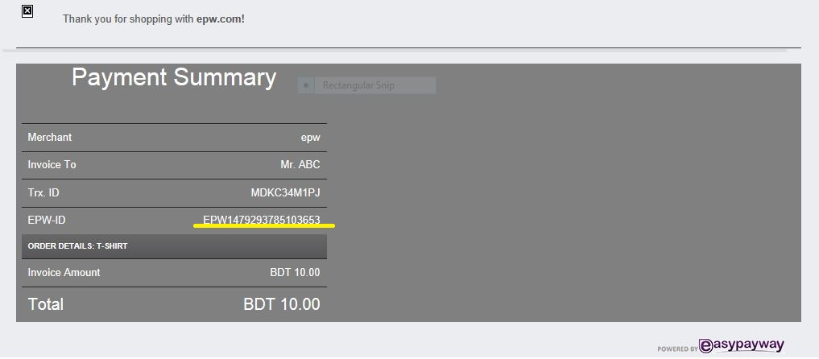

You can also see this information in Merchant’s PAYMENT->View Transaction page.

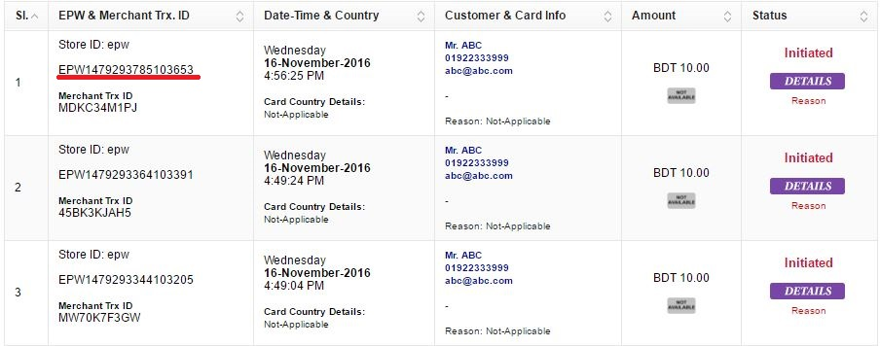

You can use the following credentials to access Merchant’s page.

**Panel Access URL:** <https://easypayway.com/merchant/>   
**Username:** [epw@epw.com](mailto:epw@epw.com)  
**Password:** 575562  
**Signature Key:** 4177203741eb46f10addfe41babec746

*EasyPayWay Gateway Integration Documentation || The Codero Limited @ 2015*

After redirecting (Live Production Environment), you will see a page similar like the following:

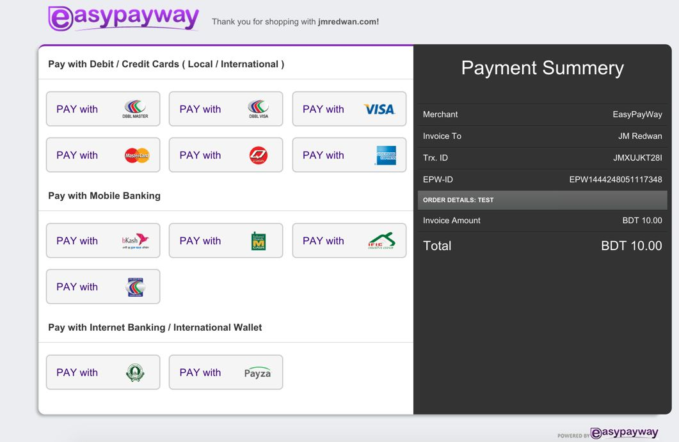

For Post Method

**You need to change the calling url as below**

● Sandbox (for testing): [http://epwsandbox.com/payment/index.php](http://sandbox.easypayway.com/payment/index.php)

● Live (production): https://securepay.easypayway.com/payment/index.php

*EasyPayWay Gateway Integration Documentation || The Codero Limited @ 2015*

EasyPayWay Return Variables Details

When a Transaction completed process from bank end then easypayway return the transactions details to merchant website. The below listed variables is return to merchant website success/fail/cancel URL.

|  |  |
| --- | --- |
| **Field Name** | **Description** |
| pay_status | Status of the transaction: ­ Failed / Successful |
| status_code | Payment Status Code: 2 or 7 |
| epw_txnid | EasyPayWay Unique Transaction ID example: EPW142322323232 |
| amount | Amount in Bangladeshi Taka example: 9700.00 |
| mer_txnid | Merchant Transaction ID example: EPW001 |
| merchant_id | Merchant ID example: epw |
| store_id | Merchant Store ID example: epw |
| currency | It will be always BDT |
| currency_merchant | Merchant Currency examples: BDT, USD, GBP |
| convertion_rate | Current Conversion Rate example: 77.79 |
| store_amount | Merchant Receivable Amount in BDT after deduct Service Charge |
| pay_time | Payment Process Date and Time. Format will be YYYY­MM­DD, HH:MM:SS |
| bank_txn | Merchant Bank Transaction ID |
| card_number | Card Holder Card Number. Card Number example will be like  530817XXXXXX0274 or 530817******0274 |
| card_holder | Cardholder Name |
| card_type | Payment Process Card Type. Example: VISA, MASTER, AMEX, bKash etc |
| opt_a | Option Value Return Provided by the Merchant Website |
| opt_b | Option Value Return Provided by the Merchant Website |
| opt_c | Option Value Return Provided by the Merchant Website |

*EasyPayWay Gateway Integration Documentation || The Codero Limited @ 2015*

|  |  |
| --- | --- |
| opt_d | Option Value Return Provided by the Merchant Website |
| ip_address | Card Holder IP Address at the time of the Transaction |
| reason | Payment Success or Failed Reason. For Success it will be like 000 |
| other_currency | Merchant Provided Currency Amount |
| success_url | Success URL return for records |
| fail_url | Failed URL Return for records |
| epw_service_charge_bdt | EasyPayWay Service Charge amount in BDT |
| epw_service_charge_usd | EasyPayWay Service Charge Amount in Merchant Currency |
| epw_card_bank_name | Success Transaction Cardholder Bank Name |
| epw_card_bank_country | Success Transaction Cardholder Bank Country |
| risk_level | Success Transactions Risk Level ­ Result will 0 for no risk and 1 for may be risky |
| epw_error_code_details | Card Payment Declined Reason Details |

*EasyPayWay Gateway Integration Documentation || The Codero Limited @ 2015*

11

Additional Integration Guidelines

Check Payment Status

For Lookup For a transaction Details you need to request below way. Anytime you can call the payment status api to grab the payment details.

The following *endpoints* address our two environments to call transaction details anytime:

● Sandbox (for testing) :

[http://epwsandbox.com/api/v1/trxcheck/request.php](http://sandbox.easypayway.com/api/v1/trxcheck/request.php)

● Live (production) :

https://securepay.easypayway.com/api/v1/trxcheck/request.php

**Lookup Call Method**

Call the endpoint URL using the below variables

1. request_id [ Merchant Transaction ID ]

2. store_id [ Merchant Store ID ]

3. signature_key [ Merchant Signature Key ]

4. type [ Call type xml or json ]

***Sandbox Test Enviroment Example:***

[http://epwsandbox.com/api/v1/trxcheck/request.php](http://sandbox.easypayway.com/api/v1/trxcheck/request.php)?**request_id**=1011&**store**

**_id**=epw&**signature_key**=dc0c2802bf04d2ab3336ec21491146a3&**type**=xml

***Live Production Enviroment Example:*** https://securepay.easypayway.com/api/v1/trxcheck/request.php?**request_id**=1011&**st ore_id**=epw&**signature_key**=dc0c2802bf04d2ab3336ec21491146a3&**type**=json

***API Response Result Output Variables***

|  |  |
| --- | --- |
| **Field Name** | **Description** |
| epw_txnid | EasyPayWay Unique Transaction ID |
| mer_txnid | Merchant Transaction ID |
| risk_title | Transaction Risk Title : Safe or Risk |
| risk_level | Transaction Risk Status Code : 0 or 1 [ 0 means Safe and 1 means Risk ] |

*EasyPayWay Gateway Integration Documentation || The Codero Limited @ 2015*

12

|  |  |
| --- | --- |
| merchant_id | Merchant ID |
| store_id | Merchant Store ID |
| amount | It will be always BDT. Actual Payment Amount in BDT |
| pay_status | Status of the transaction: ­ Failed / Successful |
| status_code | EasyPayWay Transaction Status Code |
| status_title | EasyPayWay Payment Status Title Successful Transaction or Failed  Transaction or Payment Not Yet Received |
| cardnumber | Card Holder Card Number. Card Number example will be like  530817XXXXXX0274 or 530817******0274 |
| payment_processor | Merchant Processor Bank Code example: BBL, DBBL, TCB, JBL |
| bank_trxid | Merchant Bank Transaction ID |
| payment_type | Payment Process Card Type. Example: VISA, MASTER, AMEX, bKash etc |
| error_code | Payment Error Code for decline payment |
| error_title | Payment Error Code meaning title for decline payment |
| bin_country | Payment Card Issuer Country |
| bin_issuer | Payment Card Issuer Bank Name |
| bin_cardtype | Payment Card Type example: DEBIT, CREDIT, INFINITE |
| bin_cardcategory | Payment Card Category example: ELECTRON, CLASSIC, SIGNATURE |
| date | Payment Date and Time. Format will be YYYY­MM­DD, HH:MM:SS |
| date_processed | Payment Process Date and Time. Format will be YYYY­MM­DD, HH:MM:SS |
| amount_currency | Merchant Currency Process Amount example : 90 |
| rec_amount | After EasyPayWay Charged Receivable Amount. Always in BDT |
| processing_ratio | EasyPayWay Service Charge Ratio in Percentage |
| processing_charge | EasyPayWay Service Charge Ratio amount in BDT |
| ip | Transaction Customer Source IP Address |
| currency | Merchant Converted Currency, Always BDT |

*EasyPayWay Gateway Integration Documentation || The Codero Limited @ 2015*

13

|  |  |
| --- | --- |
| currency_merchant | Merchant Currency examples: BDT, USD, GBP |
| convertion_rate | Merchant Currency to BDT Conversation Rate |
| opt_a | Option Value Return Provided by the Merchant Website |
| opt_b | Option Value Return Provided by the Merchant Website |
| opt_c | Option Value Return Provided by the Merchant Website |
| opt_d | Option Value Return Provided by the Merchant Website |
| verify_status | If its Risk Transaction or Hold status then Verification Required. Here it will impact the status of the verification |
| final_reason | Transaction Current Details Status by EasyPayWay. If Status Code is not 2 then the reason will be available in this section |
| call_type | Here the Transaction Create Order Type will be available example: Post or API |
| email_send | EasyPayWay notify merchant by email. If status 1 then Email is send if status 0 then email still in queue to process sending. |
| doc_recived | If Supporting Documents Submitted it will updated in here as Received |
| checkout_status | If this Transaction Amount Paid to Merchant then Paid ID will be shown otherwise its will show Not­Yet­Paid |

*EasyPayWay Gateway Integration Documentation || The Codero Limited @ 2015*

14

Lookup For a transaction Details Output

**Sample Output Result [ XML ]**

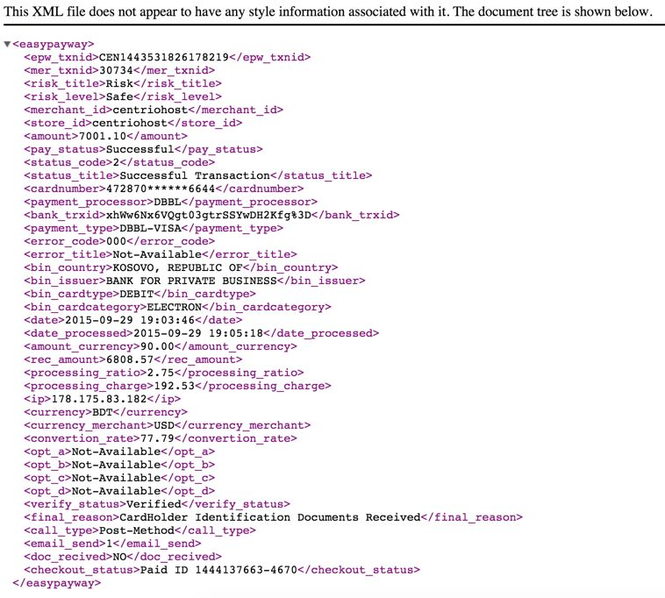

*EasyPayWay Gateway Integration Documentation || The Codero Limited @ 2015*

**Sample Output Result [ JSON ]**

{

"epw_txnid":"EPW1444230652117529", "mer_txnid":"EA4V9QSSW3", "risk_title":"Safe", "risk_level":"0", "merchant_id":"epw", "store_id":"epw",

"amount":"10.00", "pay_status":"Successful", "status_code":"2", "status_title":"Successful Transaction", "cardnumber":"IBBL­mCash", "payment_processor":"IBBL",

"bank_trxid":"0d3ea8f1da7e3cf366f426f35acd90a4a56b1bbd0c1657ef72a3716975af59de", "payment_type":"IBBL­mCash",

"error_code":"Not­Available", "error_title":"Not­Available", "bin_country":"BANGLADESH", "bin_issuer":"Islami Bank Limited", "bin_cardtype":"Mobile Banking", "bin_cardcategory":"DEBIT", "date":"2015­10­07 21:10:52", "date_processed":"2015­10­08 1:25:31", "amount_currency":"10.00", "rec_amount":"9.82", "processing_ratio":"1.75", "processing_charge":"0.18", "ip":"117.20.41.3",

"currency":"BDT", "currency_merchant":"BDT", "convertion_rate":"Not­Available", "opt_a":"Not­Available", "opt_b":"Not­Available", "opt_c":"Not­Available", "opt_d":"Not­Available", "verify_status":"PENDING", "call_type":"Post­Method", "email_send":"1", "doc_recived":"NO", "checkout_status":"Not­Paid­Yet"

}

*EasyPayWay Gateway Integration Documentation || The Codero Limited @ 2015*

IPN URL System

Below Variables will push to Merchant IPN URL. You have to received

|  |  |
| --- | --- |
| **Field Name** | **Description** |
| epw_txnid | EasyPayWay Unique Transaction ID |
| mer_txnid | Merchant Transaction ID |
| risk_title | Transaction Risk Title : Safe or Risk |
| risk_level | Transaction Risk Status Code : 0 or 1 [ 0 means Safe and 1 means Risk ] |
| merchant_id | Merchant ID |
| store_id | Merchant Store ID |
| amount_bdt | It will be always BDT. Actual Payment Amount in BDT |
| pay_status | Status of the transaction: ­ Failed / Successful |
| status_code | EasyPayWay Transaction Status Code |
| status_title | EasyPayWay Payment Status Title Successful Transaction or Failed  Transaction or Payment Not Yet Received |
| cardnumber | Card Holder Card Number. Card Number example will be like  530817XXXXXX0274 or 530817******0274 |
| payment_processor | Merchant Processor Bank Code example: BBL, DBBL, TCB, JBL |
| bank_trxid | Merchant Bank Transaction ID |
| payment_type | Payment Process Card Type. Example: VISA, MASTER, AMEX, bKash etc |
| error_code | Payment Error Code for decline payment |
| error_title | Payment Error Code meaning title for decline payment |
| bin_country | Payment Card Issuer Country |
| bin_issuer | Payment Card Issuer Bank Name |
| bin_cardtype | Payment Card Type example: DEBIT, CREDIT, INFINITE |
| bin_cardcategory | Payment Card Category example: ELECTRON, CLASSIC, SIGNATURE |
| date | Payment Date and Time. Format will be YYYY­MM­DD, HH:MM:SS |

*EasyPayWay Gateway Integration Documentation || The Codero Limited @ 2015*

|  |  |
| --- | --- |
| date_processed | Payment Process Date and Time. Format will be YYYY­MM­DD, HH:MM:SS |
| amount_currency | Merchant Currency Process Amount example : 90 |
| rec_amount | After EasyPayWay Charged Receivable Amount. Always in BDT |
| processing_ratio | EasyPayWay Service Charge Ratio in Percentage |
| processing_charge | EasyPayWay Service Charge Ratio amount in BDT |
| ip | Transaction Customer Source IP Address |
| currency | Merchant Converted Currency, Always BDT |
| currency_merchant | Merchant Currency examples: BDT, USD, GBP |
| convertion_rate | Merchant Currency to BDT Conversation Rate |
| opt_a | Option Value Return Provided by the Merchant Website |
| opt_b | Option Value Return Provided by the Merchant Website |
| opt_c | Option Value Return Provided by the Merchant Website |
| opt_d | Option Value Return Provided by the Merchant Website |
| verify_status | If its Risk Transaction or Hold status then Verification Required. Here it will impact the status of the verification |
| final_reason | Transaction Current Details Status by EasyPayWay. If Status Code is not 2 then the reason will be available in this section |
| call_type | Here the Transaction Create Order Type will be available example: Post or API |
| email_send | EasyPayWay notify merchant by email. If status 1 then Email is send if status 0 then email still in queue to process sending. |
| doc_recived | If Supporting Documents Submitted it will updated in here as Received |
| checkout_status | If this Transaction Amount Paid to Merchant then Paid ID will be shown otherwise its will show Not­Yet­Paid |

*EasyPayWay Gateway Integration Documentation || The Codero Limited @ 2015*

18

Payment Status Code Meaning

|  |  |  |
| --- | --- | --- |
| **Payment Status Code Meaning** | | |
| **Status Code** | **Status Title** | **Status Details** |
| 0 | Initiated | Customer Attempt to Payment Page But  Not Put any Payment information |
| 1 | Attempt | Customer Attempt to Payment Page But Not Put any Payment Information in the Bank Page |
| 2 | Successful | Customer Successfully Made the  Payment |
| 3 | Canceled | Customer Provide Payment Information to Bank page but payment not  approved by bank |
| 4 | Chargeback | Customer raise issue regarding Transactions. Need to Submit Documents against the Transactions |
| 5 | On­Hold | EasyPayWay Hold the Transaction For  Verification |
| 6 | Suspect Fraud | EasyPayWay suspect it’s a Fraud  Transaction |
| 7 | Failed | Payment Failed. Payment Decline by the Bank |
| 8 | Refunded­Bank | EasyPayWay Refund the Transaction. Actually Reverse the Transaction.  Its take around 3­5 Business days to adjust with customer card |
| 9 | Incomplete | Customer Does Not Provide the Information Perfectly. So payment cancel |
| 10 | Refund­Void | EasyPayWay Refund the Transaction. Actually Reverse the Transaction Before Settlement. Its take around  1­3 Business days to adjust with customer card. |
| 11 | Error | Customer Payment Information made error with validation. |

*EasyPayWay Gateway Integration Documentation || The Codero Limited @ 2015*

19

|  |  |  |
| --- | --- | --- |
| 12 | ChargeBack­Refund | We lost the ChargeBack and Customer Bank forced to Refund. As a result We process full refund |
| 13 | Missing­Authorised­Email | Customer Documents Missing For Risk  Transaction |
| 14 | ChargeBack­Dispute | We lost the ChargeBack and Customer Bank forced to Refund. As a result We process full refund and also Global Payment Fined us $500 |
| 15 | Settlement Void | At the Stage of Pre­Settlement We process refund. |
| 16 | Refund­Processing | Refund Processed to Bank |

*EasyPayWay Gateway Integration Documentation || The Codero Limited @ 2015*

20

Frequently asked questions (FAQ)

**1. What is the definition of API?**

The elaborate form of API is “Application programming interface.” It’s specifies how some software components should interact with each other.

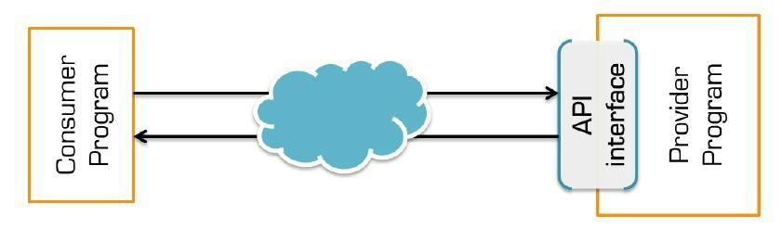

**2. What is the prerequisite to getting the EasyPayWay API?**

You need to prepare your infrastructure with proper IT Equipment (e.g. Server, PC, Data connectivity) and IT Resource (Professional programmer or Software firm collaboration)

**3. What is the purpose of API?**

Real time transaction processing against relevant services

**4. How the API Works?**

It’s work like a connector. It’s established a link between your platform with different payment channel platform like banks, mobile banking and internet banking etc.

**5. Can I validate my EasyPayWay Merchant transaction by API?**

Yes, you can validate your EasyPayWay Merchant transaction by API.

**6. What to do to get API facility?**

To get API facility you have to contact with your EasyPayWay Relationship officer or email support@easypayway.com

*EasyPayWay Gateway Integration Documentation || The Codero Limited @ 2015*

**8. Who will provide the credential of API?**

EasyPayWay will provide your credential via email. You can also email support@easypayway.com to request the credentials. Your EasyPayWay Relationship officer will provide you the detail document also

**9. EasyPayWay provide test (sandbox) environment?**

Yes EasyPayWay provide TEST (Sandbox) environment

**10. Which store id should I use in API URL?**

When get the credentials there you will find store id.

**11. If I fail to connect for some reason, then where should I inform?**

If you fail to connect you have to inform your EasyPayWay Relationship Officer or Email [support@easypayway.com](mailto:support@easypayway.com). EasyPayWay provide 24/7 full phases technical support to integrate with your system.

**12. What details will be needed to inform?**

You have to provide your merchant id by which you are trying to connect, necessary screenshots, error notifications.

**13. EasyPayWay provide ready common eCommerce platform Modules?**

Yes EasyPayWay provide. you can find the link from your merchant panel Developer Tools Menu. If you don’t find your required ready module you have to email support@easypayway.com.

**14. What will be the request method?**

HTTP(S) request method will be cURL, GET and POST

*EasyPayWay Gateway Integration Documentation || The Codero Limited @ 2015*

**15. How do I understand that API is working?**

After successful request API will respond with a EasyPayWay Transaction ID and provide you a valid forwarding URL.

**16. How do I understand that the API is not connected?**

A code for failure response will be generated, if the API is unable to get connected.

**17. Is there any sample URL of API? If yes then what is that?**

From your merchant panel you can download the sample codes. Also in this documents contain Sample codes

**18. How do I understand that the payment is successful?**

EasyPayWay return more than 30 variables.

When **pay_status** is **Successful** and **status_code** is **2** then you will understood the payment is Successful.

**19. How do I understand Payment is Risky and we need to verify the customer?**

EasyPayWay return a variables **risk_level**.

If you found the **risk_level** return result is **1** then you will understand the payment is risky. required further verification.

EasyPayWay also send you an email with Risk Transaction Alert.

**17. If after successful payment customer lost session and unable to return to our site then what happened?**

EasyPayWay have **ipn_url** system. If easypayway found that you unable to received the payment information then EasyPayWay will call your ipn_url to push the information to your end. Please discuss with your Relationship Manager to understand the process more deeply.

*EasyPayWay Gateway Integration Documentation || The Codero Limited @ 2015*

**18. What is the Merchant Panel Access URL?**

For Sandbox Merchant Panel access URL is:

[http://epwsandbox.com/merchant/](http://sandbox.easypayway.com/merchant/)

For Live Merchant Panel access URL is: https://easypayway.com/merchant/

For Panel login credentials check easypayway email or contact with your easypayway representative officer

**19. I lost my merchant panel password?**

If you lost your merchant panel access then email to [support@easypayway.com](mailto:support@easypayway.com). You will get new password to your registered email address.

**20. How i process a refund?**

For process a refund from your merchant panel you can request from the Payment > Request Refund Menu Or you can email support@easypayway.com

**21. Can i process a partial refund?**

refund

Menu.

yes you can process partial refund from the merchant panel. For process a partial from your merchant panel you can request from the Payment > Request Refund

Or you can email [support@easypayway.com](mailto:support@easypayway.com)

**22. How long will take to process a refund to customer account.?**

In general after your request it will take around 3 to 5 business days to adjust the amount to cardholder bank account.

**23. Mobile Banking Refund possible?**

any

Islami Bank Mobile Banking only support refund others mobile banking dont support

refund.

**24. Is there any additional charge for refund process?**

*EasyPayWay Gateway Integration Documentation || The Codero Limited @ 2015*

No, there is no additional charges to process the refund. For a full refund customer will get full amount to his account.

*EasyPayWay Gateway Integration Documentation || The Codero Limited @ 2015*

For Technical Support

For any technical support please email to [support@easypayway.com](mailto:support@easypayway.com). For Advance Technical Support email [admin@easypayway.com](mailto:admin@easypayway.com).

Phone Number: +8801922333999 / +88029892982

Skype: easypayway

Registred Address:

House B­158 Road 22 Mohakhali DOHS Dhaka Bangladesh

­­ END ­­

*EasyPayWay Gateway Integration Documentation || The Codero Limited @ 2015*